**June Month Report –Community Learning Centre – Beginning Process**

**Major Activities of the Month :**

1. **Community Mobilisation along with parents meeting**

**Date:** 2023-2024

**Activities Conducted:**

1. **Community Mobilization:** We initiated our community mobilization efforts across multiple areas, including Khishkoli Circle and Vasna Village. Notably, we received significant support from the residents of Khishkoli Circle, particularly from the VUDA House community, known as Shivaji Puri.
2. **Community Visits:** We visited three communities near Khishkoli Circle: Satoshi Nagar, Sarvoday Nagar, and Shivaji Puri. These visits were essential for understanding the local needs and garnering support for our initiatives.

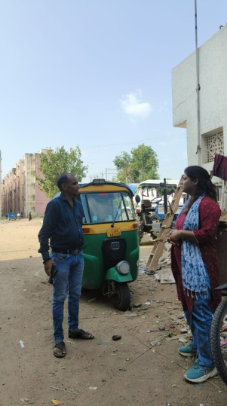

• **Parental Engagement:** We engaged with the parents, introducing them to our work and the benefits for their children. After several visits and discussions, the parents were convinced and agreed to send their children for classes.

• **Rapport Building with Students:** To establish rapport and encourage participation, we organized various games and STEM activities for the children during the initial days. This approach successfully engaged the children, who started participating actively in both the games and STEM activities.

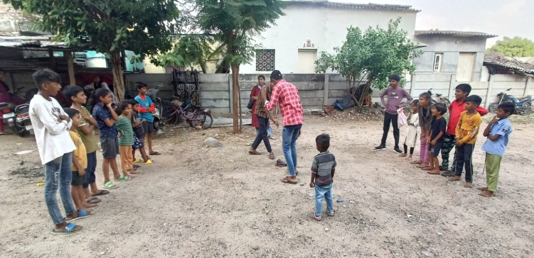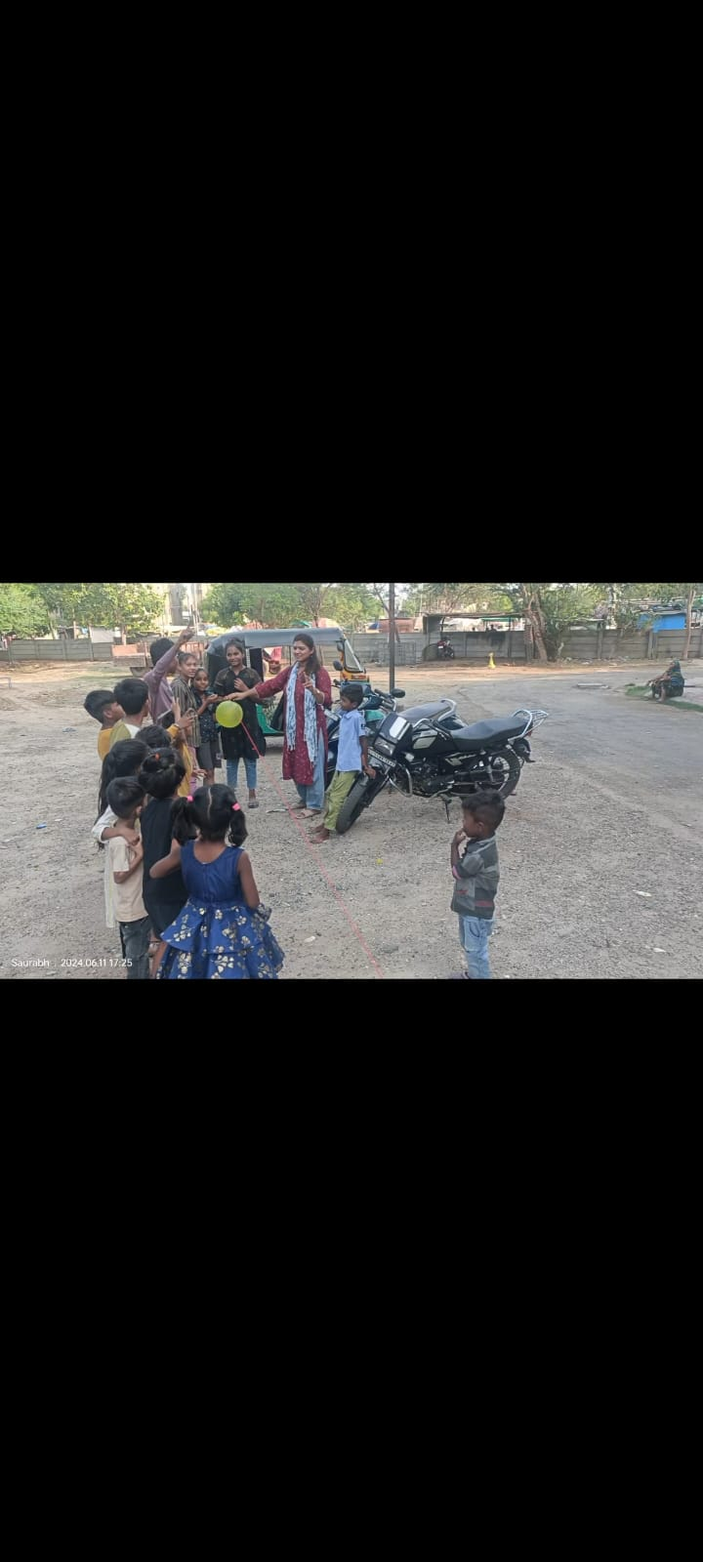

1. **Beginning of the CLC**

* We started CLC at Shivajipuri on 17th June 2024 for standard 4th to 9th.
* Our class duration is Monday to Saturday and Sunday is holiday.
* We have started classes in 2 batches. One is morning class and another in evening. Morning batch time is 8.30 am to10.00am. And evening batch time is 4.00pm to 5.30 pm.
* We have total 40 registration. A total of 18 students attend in the morning batch and 22 students attend in evening batch.

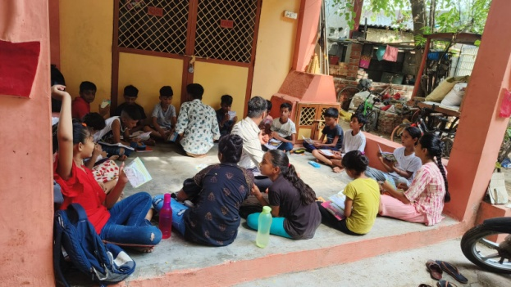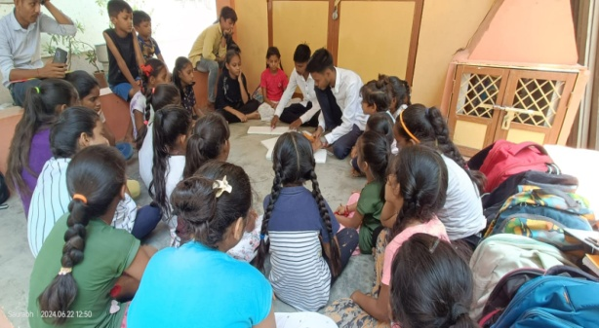

**3. Teaching in CLC**

• **Fundamentals of Gujarati and Math Teaching:** Our teachers initiated the fundamental lessons in Gujarati and Math. It was observed that many students still struggled with basic reading, writing, and mathematical skills. This highlighted the need for a strong focus on foundational education.

• **Baseline Testing:** In the second week, we administered baseline tests to evaluate the students' understanding and proficiency in Gujarati and Math. These tests aimed to measure their current learning levels and identify areas requiring further attention and support.

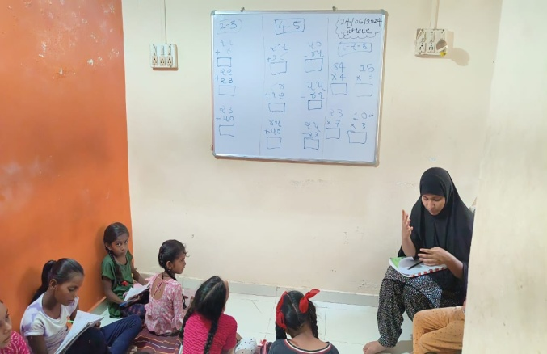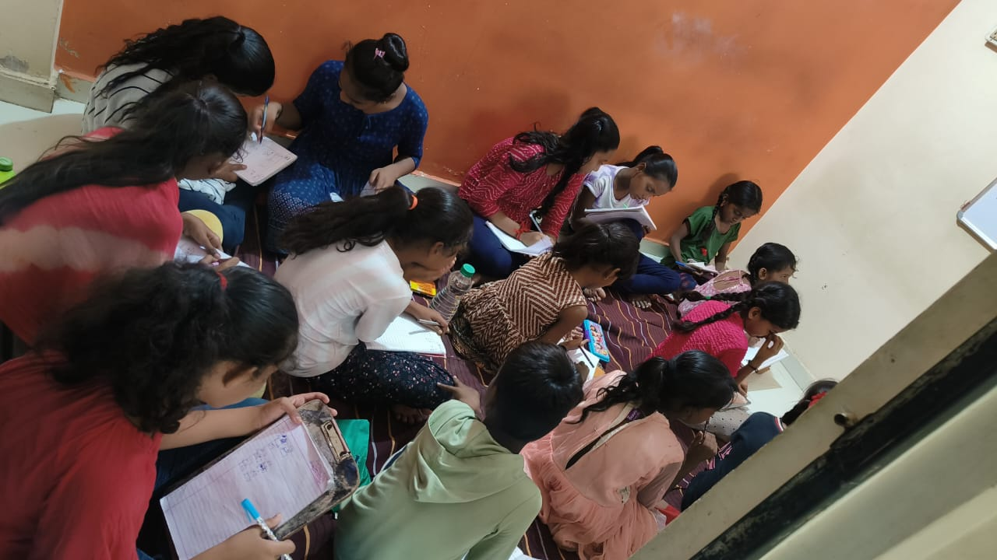

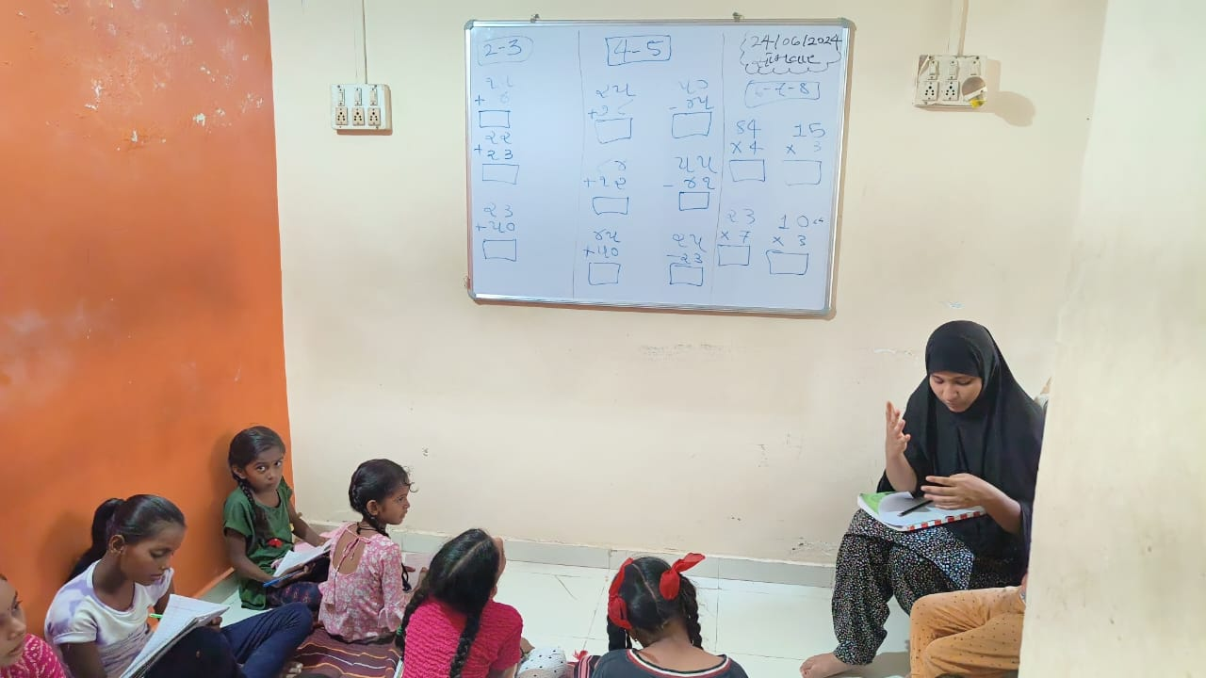

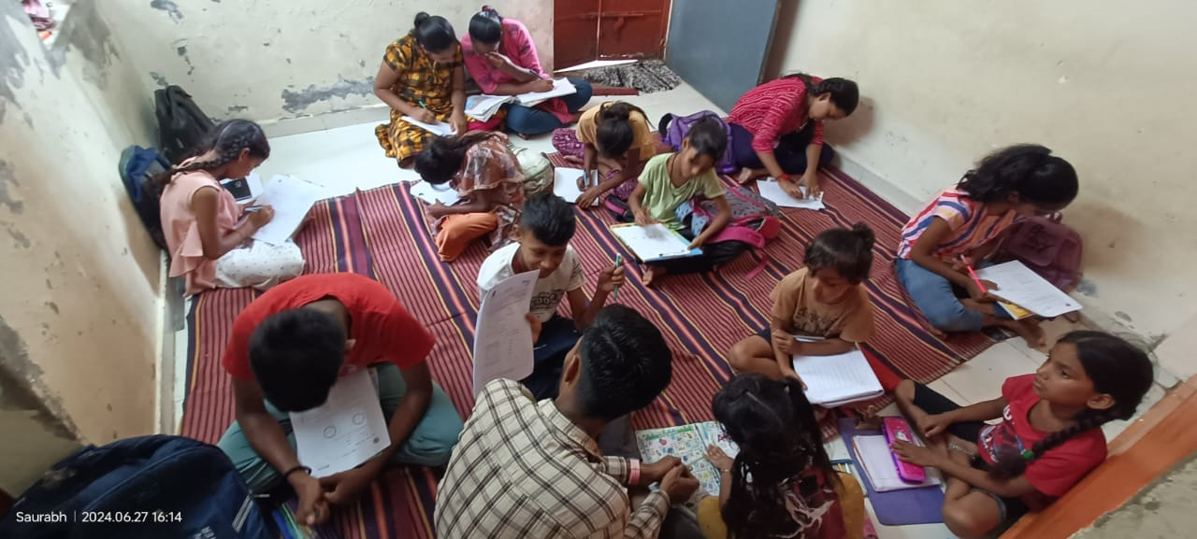

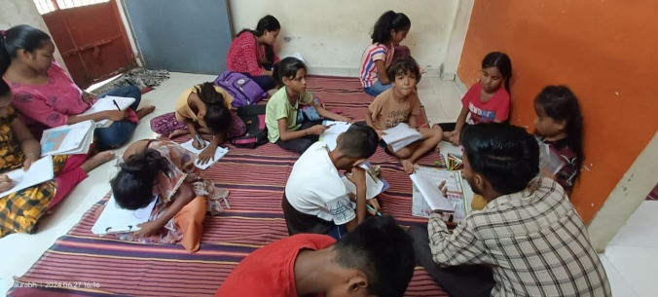

1. **Extra Activities on Saturdays**
2. **STEM Sessions:** Over the weekend, we conducted STEM activities with the CLC students. Suraj Sir led these sessions, teaching science through engaging activities. The students were highly enthusiastic and participated actively, even replicating some activities at home.
3. **STEM Activities Conducted:**
   * **Balloon Boat:** Students learned about buoyancy and propulsion by creating boats powered by the release of air from balloons.
   * **Balloon Rocket Launcher:** This activity demonstrated basic principles of physics and rocket science, showing how force and motion work through a balloon-powered rocket.
   * **Lava Lamp:** Students created their own lava lamps, learning about density and the interaction of oil, water, and effervescence.
   * **Force and Pressure with Stick and Balloon:** This activity explored the concepts of force and pressure, using simple materials to demonstrate how pressure can be distributed and managed.

**Summary:**

The STEM activities sparked great interest and excitement among the students, providing a hands-on learning experience that reinforced scientific concepts in a fun and engaging way. These activities not only enhanced their understanding of science but also encouraged them to explore and experiment further on their own.

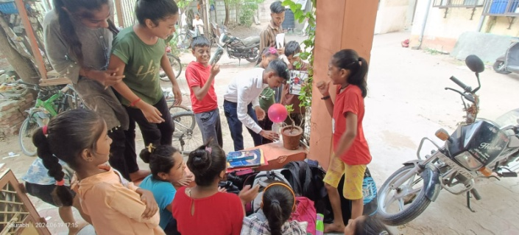

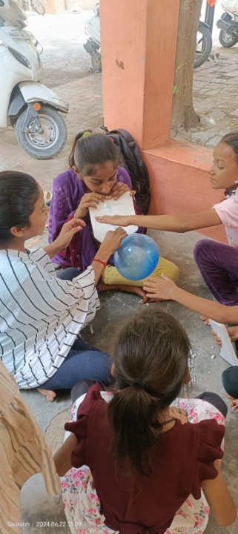

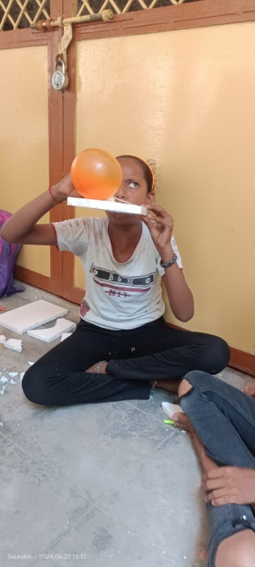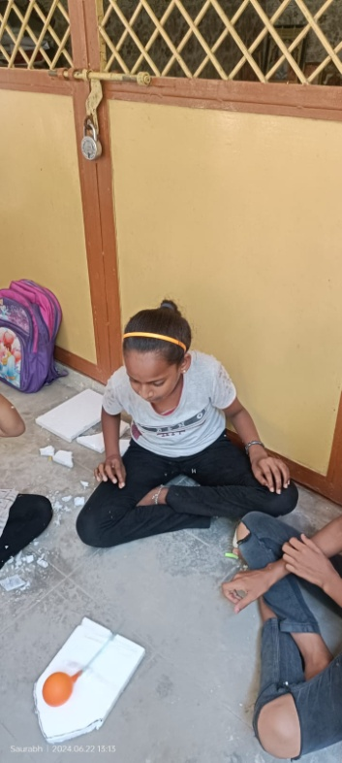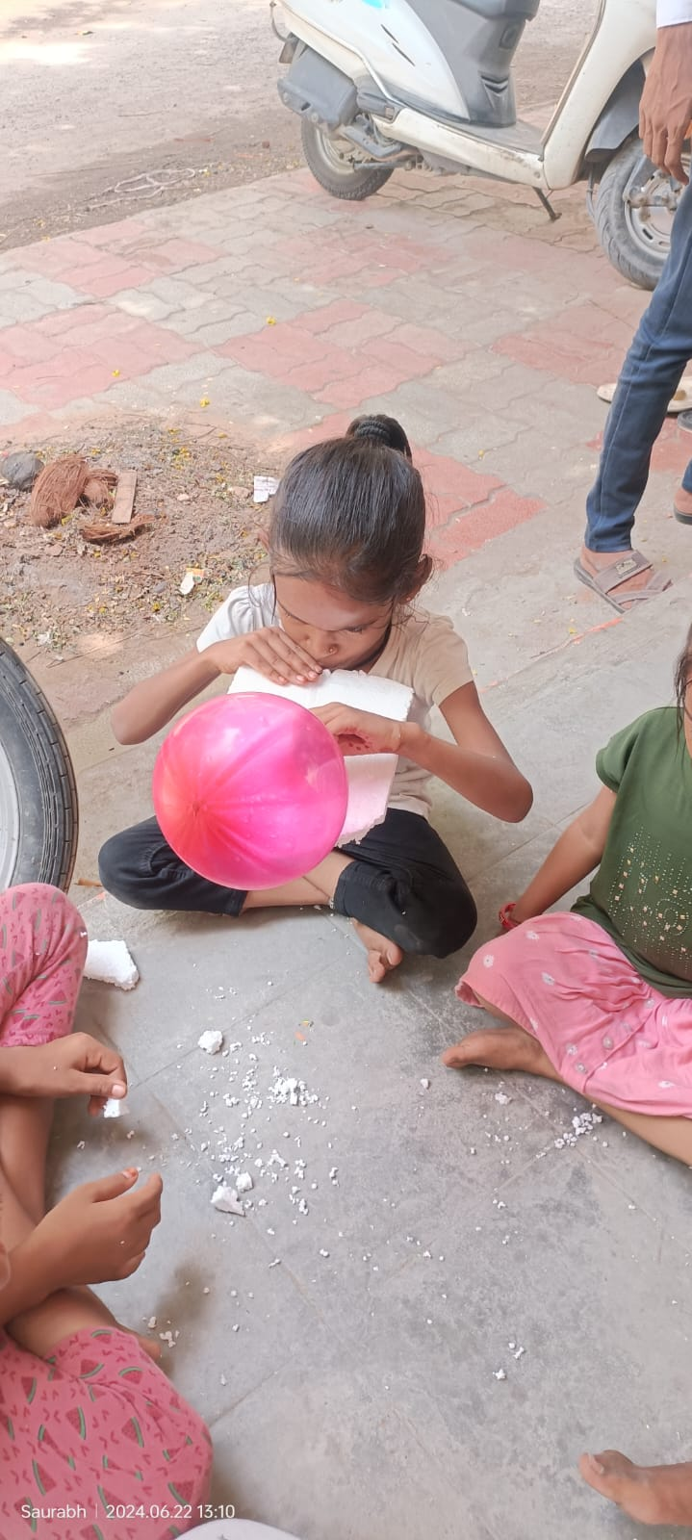

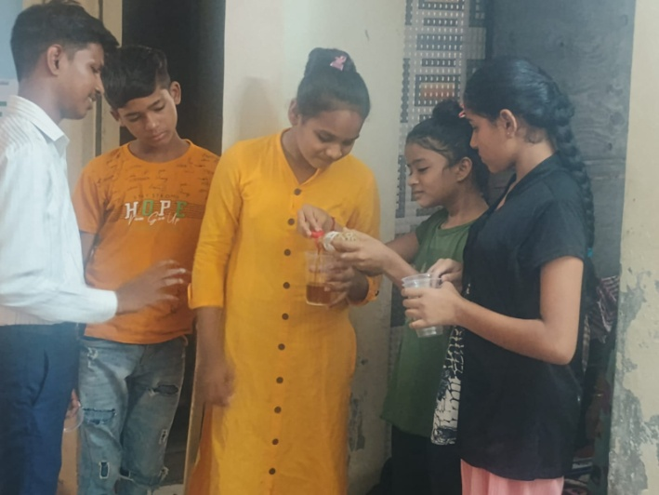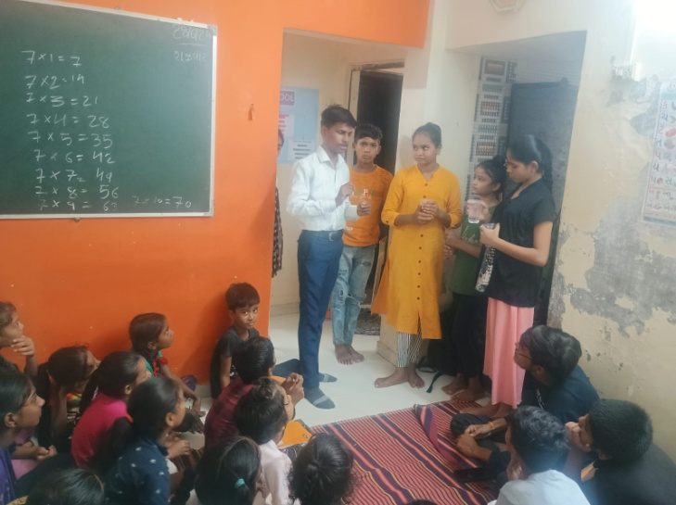

* **Celebration of International Yoga day.**

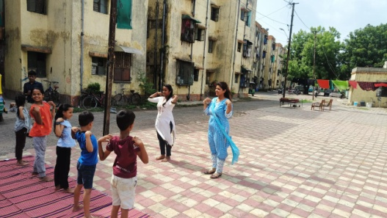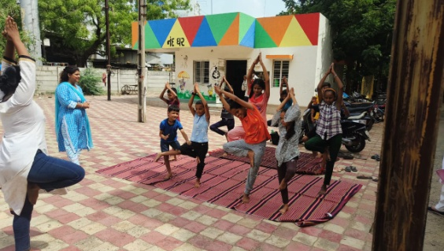

* 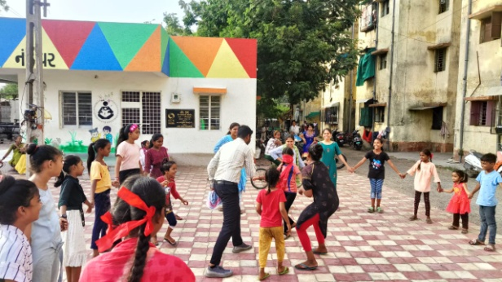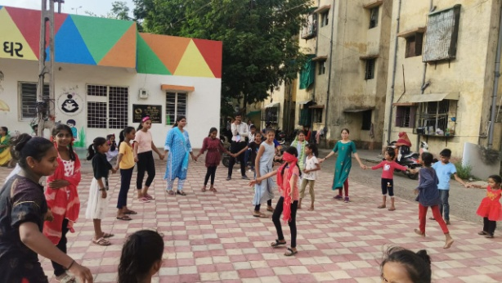**Blind fold game**

**Monthly Attendance**